**MASTER PLAN FOR CODING IN R**

The main intention for this project is to assemble the best practices for performing any analytics project in R.

Some Common Time Series Analysis Algorithms:

1. ARIMA
2. ETS
3. TSLM
4. FASSTER
5. PROPHET
6. NNETAR
7. GLM
8. KNN Regression
9. MARS Regression
10. Recurrent Neural Networks (RNNs)
11. Ensembling Multiple ML and Univariate Modeling Techniques
12. Deep Learning with RNNs.
13. TSML-GLM
14. TSML-Xgboost

**Setting Up Your Data Science Project**

* Create an R Project in the RStudio IDE (Integrated Development Environment)
* Programmatically create the directory structure using the **fs package**
* Review and install the required packages. R Packages we focus on: **h2o, lime, recipes, tidyverse, tidyquant, glue, cowplot, GGally, skimr, fs, and readxl**.
* Ctrl + enter to execute a line of code
* Alt + - for <-

**# clearing the environment and the console**

rm(list=ls()) #cleaning the environment

cat(“\014”) #cleaning the console area

**# Following are the process involved:**

1. **DS Project Setup:**
2. **R Project Setup:**

* **Great way to manage files**
* **Sets working directory**
* **Manages project settings**
* **Switching Back & Forth**

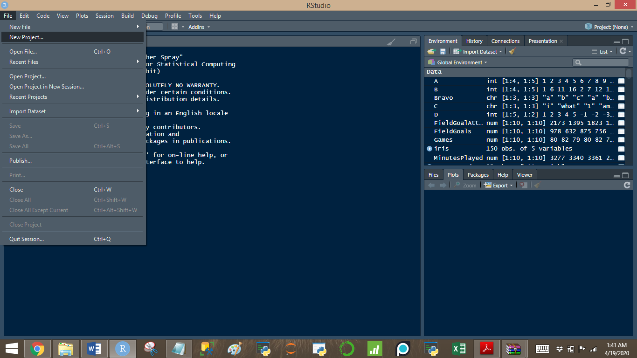

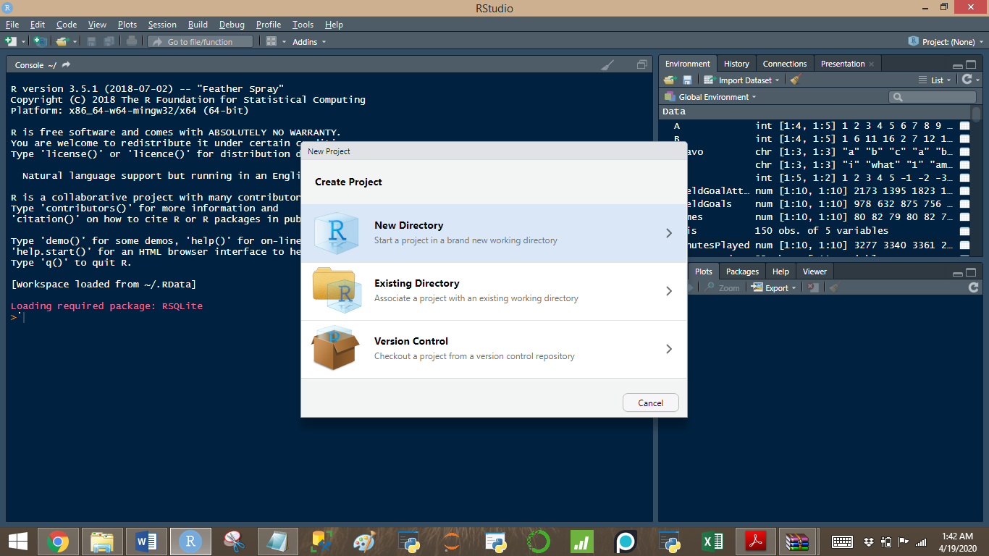

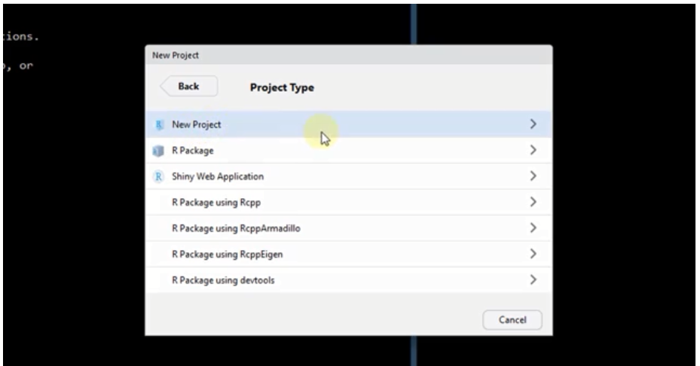

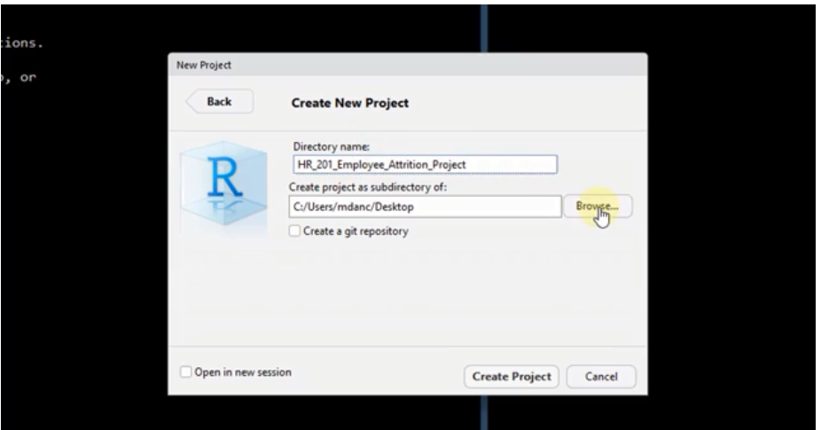

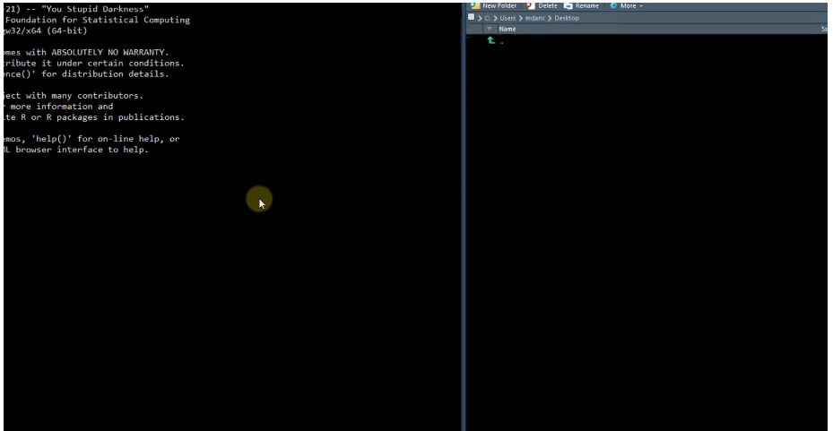

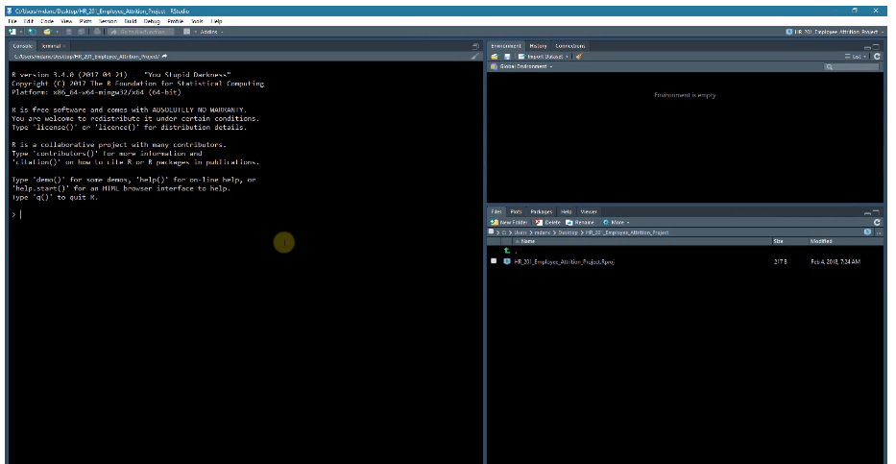

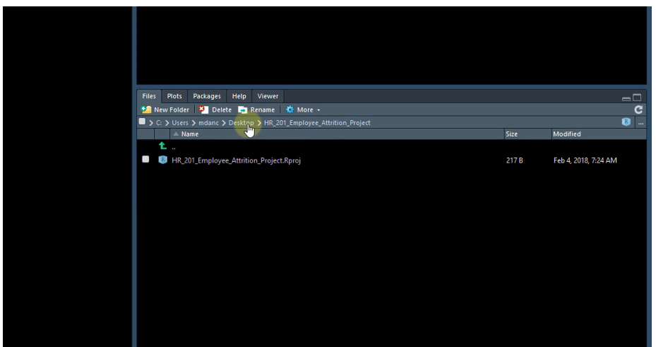



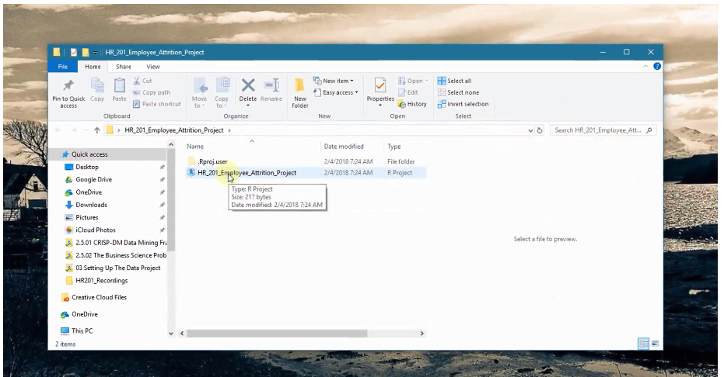

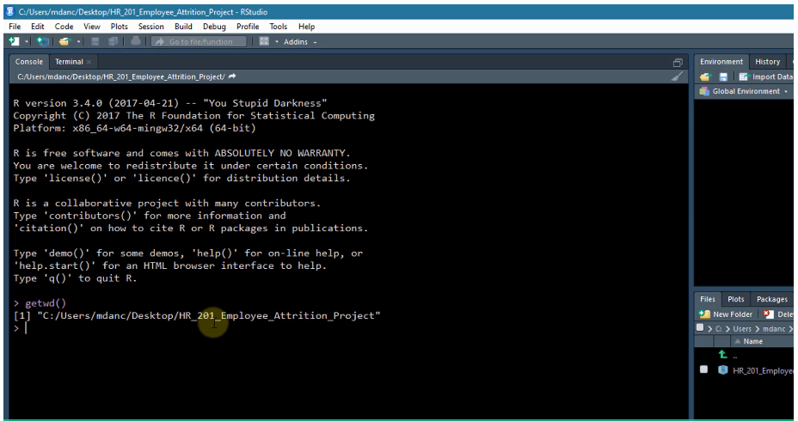

1. **Project Directory Structure:**

Directory Structure: Follows CRISP-DM Phases

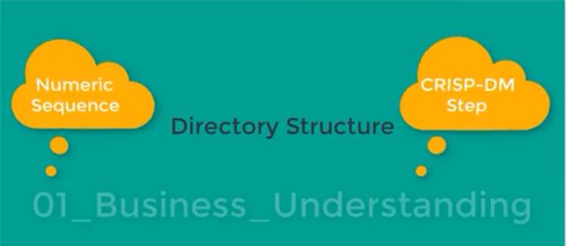

01_Business_Understanding

02_Data_Understanding

03_Data_Preparation

04_Modeling

**fs package :** folder structure, A package used for working with and manipulating the file system. Useful for working with folders, directories and file paths.

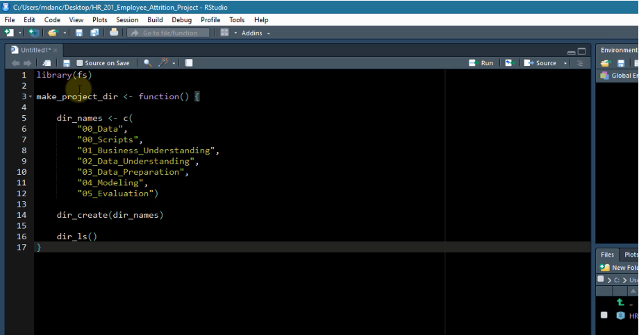

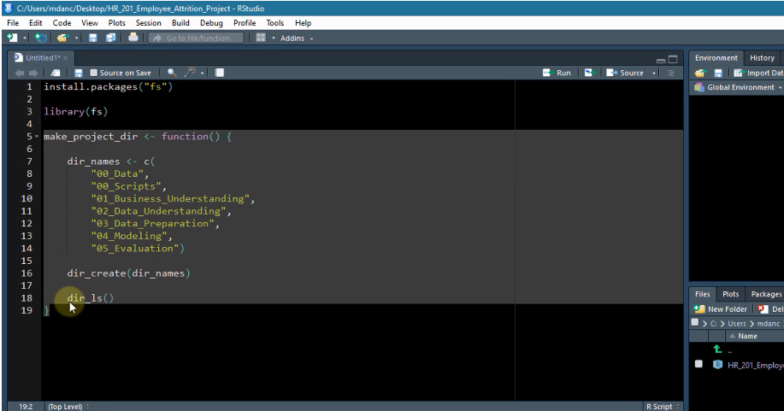

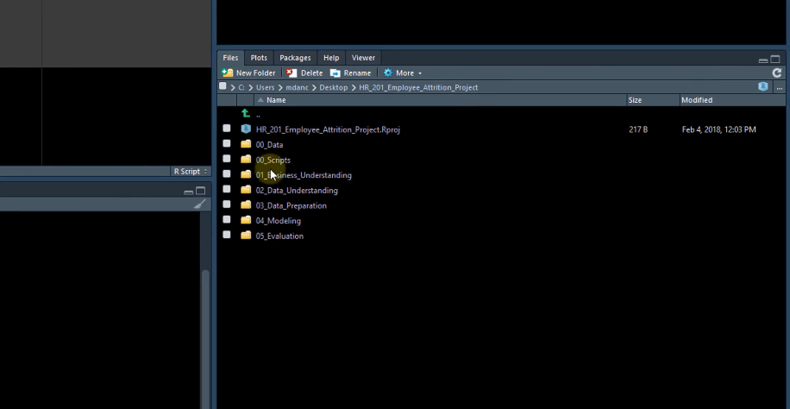

1. **Install Required Packages**
   1. **Plan A**

**# Algorithm to load packages if they are already existing or installing them if they are not previously installed. This can be sourced to the main driver code if when needed. (Say the R file name is installPackage.R save it in 00_Script folder**

pkgTest <- function(x){

if(!require(x,character.only=TRUE)){ #if the packages are not present they would be downloaded and activated

install.packages(x,dependencies=TRUE)

if(!require(x,character.only=TRUE)){

stop(“Package not found”)

}

}

}

**#When we want to load all the required packages to the main driver code**

Setwd(“The folder where the pkgTest function object is present”)

Source(“installPackage.R”)

Pkgs <- c (

“h2o”, **# High performance machine learning**

“lime”, **# Explaining black-box models**

“recipes”, **# Creating ML preprocessing recipes**

“tidyquant”, **# Financial time series pkg – Used for theme_tq ggplot2 theme**

“tidyverse”, **# Set of pkgs for data science dplyr, ggplot2, purr, tidyr…**

“glue”, **# Pasting test**

“cowplot”, **# Handling multiple ggplots**

“GGally”, **# Data understanding visualizations**

“skimr”, **# Data understanding summary information**

“fs**”, # Working with the file system – directory structure**

“readxl”, **# Reading excel files**

“writexl” **# Writing to excel files**

)

pkgTest(Pkgs)

* 1. **Plan B**

**For installing (Just once)**

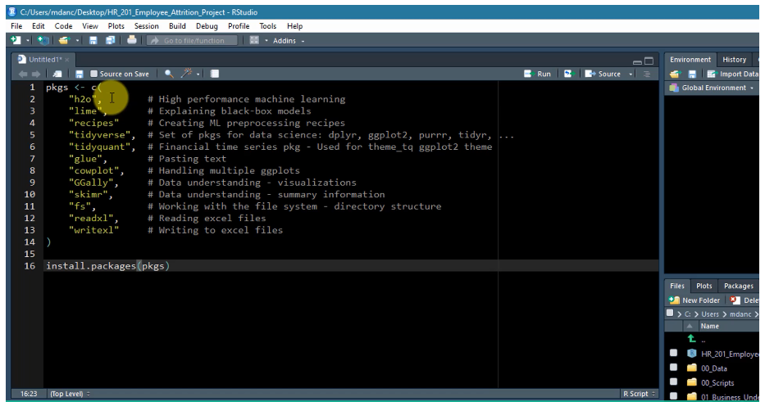

**Then activate specific Package when needed**

1. **Collect the Data Files**

**Save the excel file in the project directory**

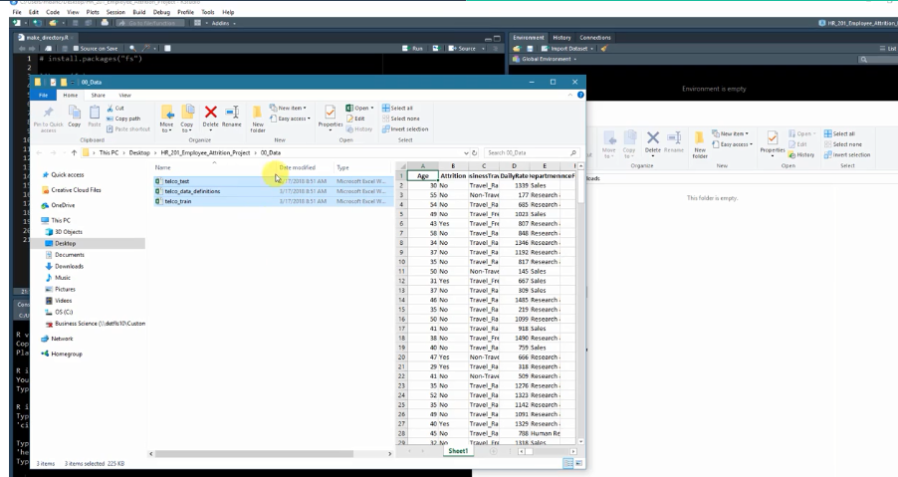

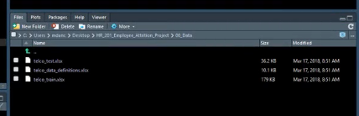

**X. Debugging Common Errors: Java related and getting coding help**

1. **Problem Understanding with Business Science Problem Resolution Framework (Save all code pertaining to this in the 01_Business_Understanding Folder, Save the code (not custom function) in Business_Understanding.R file)**
2. **Business Understanding :**

* Find the cohort (group within a population that often has specific sub-population trend),
* Identifying the sub categories within cohorts can even further help in defining relationships.

1. **Library & Data Setup**

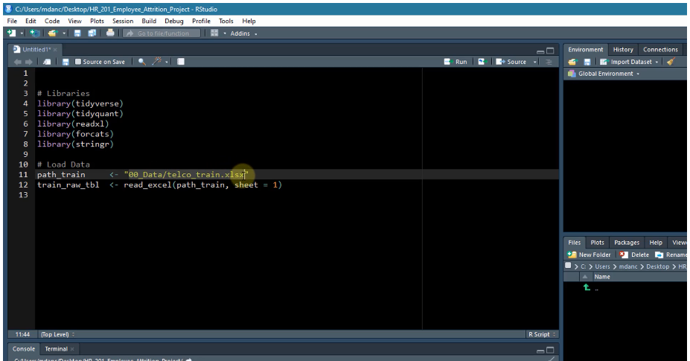

**Or use**

Source(“installPackage.R”)

pkgTest(Pkgs)

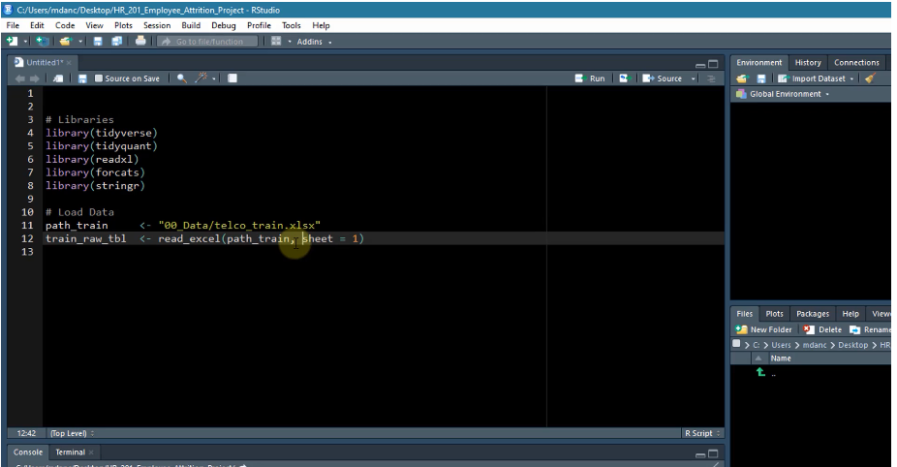

Use tab to navigate through.

Pro tip: Append your variables with a class descriptor (“_tbl”) to keep the variable organized.

1. **View the business as a machine**

* See the breakup of every categorical variable.
* Define the object, from this categorical variable observe and identify what you want to increase or decrease.
  + Group_by -> Groups a data frame (tibble) by categorical data contained in a column or set of columns
  + n() -> A special dplyr function that counts all of the unique observations
  + ungroup -> Removes group from a grouped data frame. It is a good idea to remove groups after any grouped operations are complete.
  + It is easy to inadvertently miss grouping when creating counts and percents within groups. (Effective grouping by categorical variables very vital)

1. **Understand the drivers**

* Identify the sub categories within cohorts can even further help in defining relationships. Use of group_by, ungroup, filter with %in% c(.. , ..) and summarize is very vital

1. **Measure the drivers**

* Use glimpse function
* Categorize the Features (eg. Employment Features, Compensation feature, Work-Life features etc)
* Breakdown the data collection activities into strategic areas.
* KPI: A metric that is developed to monitor critical performance measures within an organization such as those related to cost, quality, lead time. KPIs are usually based on data, which can be external (industry data) or internal (customer feedback)
* If you need information strategically “google” to see the benchmark figures. Always keep the record of the source of the data.
* Case_when() steps evaluated in order. Always end with “TRUE ~” + the value that you want items not meeting the criteria.
* Save the code in the **01_Business_Understanding** Folder
  + Eg.

Dept_job_role_tbl %>%

Group_by(Department, JobRole, Attrition) %>%

Summarize(n=n()) %>%

Ungroup() %>%

Group_by(Department, JobRole) %>%

Mutate(pct=n/sum(n)) %>%

Ungroup() %>%

Filter(Attrition %in% c(“Yes”)) %>%

Arrange(desc(pct)) %>%

Mutate(

Above_industry_avg = case_when(

Pct > 0.088 ~ “Yes”,

TRUE ~ “No”

)

)

1. **Uncover the problems & opportunities : Making customized functions wherever required**

Create a function for the KPIs if not created otherwise, It should be a linear one which is easy to calculate

Eg.

Create the script and save it in **00_Script** Folder as **KPI_indicator_fn.R** ,

Source call it to the main driver code wherever required.

Calculate_attrition_cost <- function(

}These are the default values

**# Direct Costs**

n = 1,

salary = 80000,

**#Direct Costs**

separation_cost = 500,

vacancy_cost = 10000,

acquisition_cost = 4900,

placement_cost = 3500,

**#Productivity Costs**

net_revenue_per_employee =250000,

workdays_per_year =240,

workdays_position_open =40,

workdays_onboarding =60,

onboarding efficiency =0.50

) {

**#Direct Costs**

Direct_cost <-sum(separation_cost, vacancy_cost, acquisition_cost, placement_cost)

**#Lost Productivity Costs**

Productivity_cost <-net_revenue_per_employee / workdays_per_year *

(workdays_position_open + workdays_onboarding * onboarding_efficiency)

**#Saving of Salary & Benefits (Cost Reduction)**

Salary_benefit_reduction <- salary / workdays_per_year *workdays_position_open

**# Estimated Turnover per employee**

Cost_per_employee <- direct_cost + productivity_cost – salary_benefit_reduction

**# Total Cost of Employee Turnover**

Total_cost <- n * cost_per_employee

return(total_cost)

}

Use source() from Business_Understanding.R to call InstallPkgs.R Code and Calculate_attrition_cost.R and use the function in them.

Setwd(“The folder where the Calculate_attrition_cost function object is present”)

Source(“Calculate_attrition_cost.R”)

Dept_job_role_tbl %>%

Group_by(Department, JobRole, Attrition) %>%

Summarize(n=n()) %>%

Ungroup() %>%

Group_by(Department, JobRole) %>%

Mutate(pct=n/sum(n)) %>%

Ungroup() %>%

Filter(Attrition %in% c(“Yes”)) %>%

Arrange(desc(pct)) %>%

Mutate(

Above_industry_avg = case_when(

Pct > 0.088 ~ “Yes”,

TRUE ~ “No”

)

) %>%

Mutate(

Cost_of_attrition = calculate_attrition_cost(n=n, salary=80000)

)

* In the above code the code follow logical steps repeated frequently, multiple people use same workflow, redundant code can be abstracted (like summarize, ungroup, mutate, arrange etc ) so that we can only see what we want and not the entire line of code (we can create custom functions wherever required in the place of the abstracted codes).

This is a great way to manage the code flows

We can do the abstraction in the Business_Understanding. R file itself as this would be used in this file alone

Dept_job_role_tbl %>%

**Dplyr::count()**

Group_by(Department, JobRole, Attrition) %>%

Summarize(n=n()) %>%

Ungroup() %>%

Group_by(Department, JobRole) %>%

**Count_to_pct()**

Mutate(pct=n/sum(n)) %>%

Ungroup() %>%

Filter(Attrition %in% c(“Yes”)) %>%

Arrange(desc(pct)) %>%

Mutate(

**Assess_attrition()**

Above_industry_avg = case_when(

Pct > 0.088 ~ “Yes”,

TRUE ~ “No”

)

) %>%

Mutate(

Cost_of_attrition = calculate_attrition_cost(n=n, salary=80000)

)

**Dplyr::count()**

Dept_job_role_tbl %>%

Count(JobRole, Attrition) %>%

**Count_to_pct <- function (data,…, col= n) { # ... let us enter variables without quotes**

**Grouping_vars_expr <- quos(…) # quos and enquo function from Tidyeval Package help**

**# take multiple variable**

**Col_expr <- enquo(col) # we can also take enquo (mostly used for numeric**

**Ret <- data %>%**

**Group_by(!!! Grouping_vars_expr) %>% # !!! for categorical data**

**Mutate(pct=(!!col_expr)/sum(!!col_expr)) %>% # !! for numerical data**

**Ungroup()**

**Return(Ret)**

**}**

Count_to_pct(JobRole) %>%

**Assess_attrition()**

**Assess_attrition <- function(data,attrition_col, attrition_value, baseline_pct) {**

**Attrition_col_expr <- enquo(attrition_col)**

**data %>%**

**filter((!!attrition_col_expr) %in%attrition_value) %>%**

**# attrition_col is Attrition, Attrition_value is “Yes” or “No”,**

**Baseline_pct is the benchmark figure**

**arrange(desc(pct)) %>%**

**mutate(**

**above_industry_avg = case_when(**

**pct > baseline_pct ~ “Yes”,**

**TRUE ~ “No”**

**)**

**)**

Assess_attrition(Attrition, attrition_value=

”Yes”, baseline_pct = 0.088) %>%

%>%

Mutate(

Cost_of_attrition = calculate_attrition

_cost(n=n, salary=80000)

)

Tidyeval Frameowork: <https://tidyeval.tidyverse.org/>

Quo and enquo , we can use any where but !! is used when we try to refer to any value of the input variable with == or %in% (%in% using filter), when we want to use it for that purpose we use enquo for that variable entered in the function.

Quo is used when we are trying to group_by some variable.

**\*As per my understanding, when to use quo, enquo, !!! and !!**

|  |  |
| --- | --- |
| **quo** | **enquo** |
| * !!! goes with quo * Used when we want to use variables for group_by subsequently. * 1. In the function we use … for entering multiple variable in group_by   2. quo_expr <- quo(…)  We enter the variables by its name, without quotes and inside the function we catch those variables with quotes with quo function.  3. we use !!! to group_by those variables. | * !! goes with enquo * Used when we want to do   A. algebraic operation on a variable, B. logical comparison on a variable entered via quo to check it matches particular value/level of that variable <entered using enquo>.   * 1. In the function we use an argument to enter the variable or enter the level of the variable. This entered without quotes   2. Inside the function we absorb the function argument with enquo (which quotes the entry) and keep it in a new object enquo_expr.  3. We can use !! when we want to use the enquo_expr object. |

1. **Assessing the count and Percentage Calculations**

Make relevant conclusions / inferences from the above function and coding.

1. **Making custom plotting functions:**
2. **Visualizing the cost and other continuous parameters related to the problem at hand with ggplot2, GGally, gt, ggcharts packages**

**Ggcharts example:**

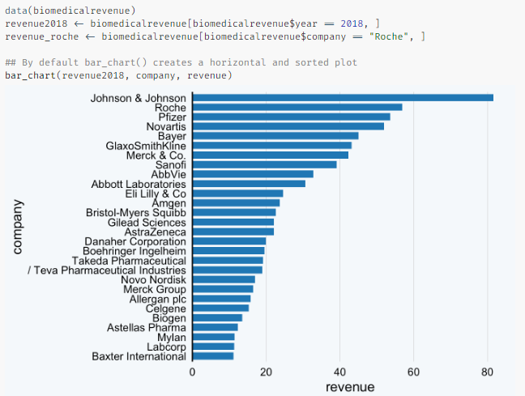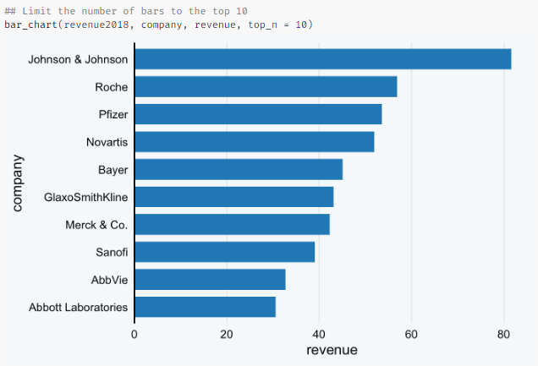

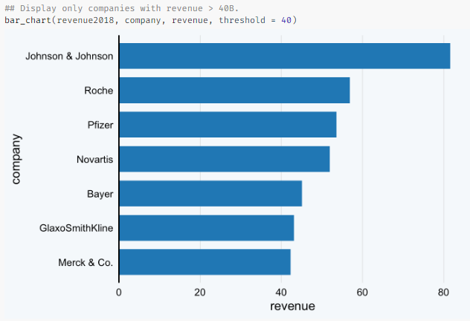

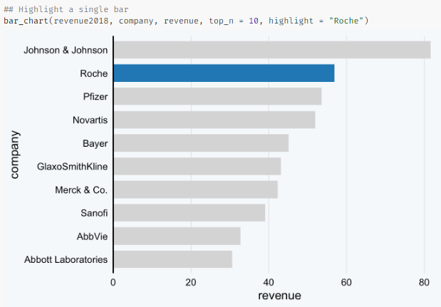

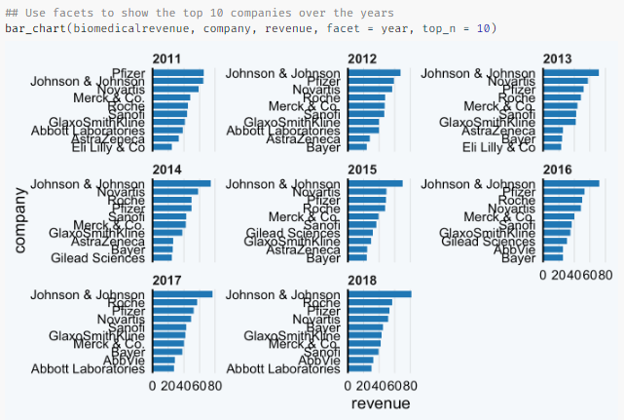

<https://thomas-neitmann.github.io/ggcharts/reference/index.html>

**Mutate() adds new variables and preserves existing ones; transmute() adds new variables and drops existing ones. Both functions preserve the number of rows of the input. New variables overwrite existing variables of the same name.**

1. **Making custom functions for regular tweak to the code.**

Dept_job_role_tbl %>%

Count(JobRole, Attrition) %>%

**Count_to_pct <- function (data,…, col= n) { # ... let us enter variables without quotes**

**Grouping_vars_expr <- quos(…) # quos and enquo function from Tidyeval Package help**

**# take multiple variable**

**Col_expr <- enquo(col) # we can also take enquo (mostly used for numeric**

**Ret <- data %>%**

**Group_by(!!! Grouping_vars_expr) %>% # !!! for categorical data**

**Mutate(pct=(!!col_expr)/sum(!!col_expr)) %>% # !! for numerical data**

**Ungroup()**

**Return(Ret)**

**}**

Count_to_pct(JobRole) %>%

**Assess_attrition()**

**Assess_attrition <- function(data,attrition_col, attrition_value, baseline_pct) {**

**Attrition_col_expr <- enquo(attrition_col)**

**data %>%**

**filter((!!attrition_col_expr) %in%attrition_value) %>%**

**# attrition_col is Attrition, Attrition_value is “Yes” or “No”,**

**Baseline_pct is the benchmark figure**

**arrange(desc(pct)) %>%**

**mutate(**

**above_industry_avg = case_when(**

**pct > baseline_pct ~ “Yes”,**

**TRUE ~ “No”**

**)**

**)**

Assess_attrition(Attrition, attrition_value=

”Yes”, baseline_pct = 0.088) %>%

Mutate(

Cost_of_attrition = calculate_attrition

_cost(n=n, salary=80000)

) %>%

**# Data Manipulation:**

Mutate(name=str_c(Department, JobRole, sep = “: ”) %>%

as.factor()) %>%

mutate(name =fct_reorder(name, cost_of_attrition)) %>% # Reorder factor levels by sorting along another variable, It is **forcats** package, **fct_reorder()**is useful for 1d displays where the factor is mapped to position;

mutate(cost_text=str_c(“$”, format(cost_of_attrition/1e6, digits =2),

“M”, sep=””)) %>%

**# Plotting:**

ggplot(aes(x=cost_of_attrition, y= name)) +

geom_segment(aes(xend=0, yend=name), color =palette_light()[[1]]) +

geom_point(aes(size=cost_of_attrition), color= palette_light()[[1]]) +

scale_x_continuous(labels = scales::dollar) +

geom_label(aes(label = cost_text, size= cost_of_attrition),

hjust = “inward”, color = palette_light()[[1]]) +

theme_tq() +

scale_size(range= c(3,5)) +

labs(title=”Estimated Cost of Attrition: By Dept and Job Role”,

y=””, x=”Cost of Attrition”) +

theme(legend_position = “none”)

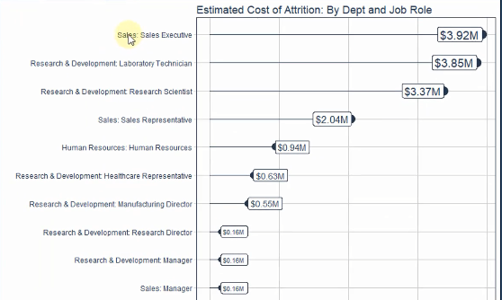

|  |  |
| --- | --- |
| **# Conventional Plotting:** | **Custom function (This need the Conventional plotting function to be created and based on it Custom function is created)** |
| **…………….** ggplot(aes(x=cost_of_attrition, y= name)) +  geom_segment(aes(xend=0, yend=name), color =palette_light()[[1]]) +  geom_point(aes(size=cost_of_attrition), color= palette_light()[[1]]) +  scale_x_continuous(labels = scales::dollar) +  geom_label(aes(label = cost_text, size= cost_of_attrition),  hjust = “inward”, color = palette_light()[[1]]) +  theme_tq() +  scale_size(range= c(3,5)) +  labs(title=”Estimated Cost of Attrition: By Dept and Job Role”,  y=””, x=”Cost of Attrition”) +  theme(legend_position = “none”) | **Plot_attrition(Department, JobRole, .value=cost_of_attrition, units=”M”)**  plot_attrition <- function(data, ..., .value,  fct_reorder = TRUE,  fct_rev = FALSE,  include_lbl = TRUE,  color = palette_light()[[1]],  units = c("0", "K", "M")) {      **# Inputs**    group_vars_expr <- quos(...) **#Tidyeval way of getting only the variables for grouping**  if (length(group_vars_expr) == 0)  group_vars_expr <- quos(rlang::sym(colnames(data)[[1]])) **#rlang package sym function used to access the 1st column name inside function**    value_expr <- enquo(.value) **#accessing the values (not the variable names)**  value_name <- quo_name(value_expr) **#?? Why do we need it?**    units_val <- switch(units[[1]],  "M" = 1e6,  "K" = 1e3,  "0" = 1)  if (units[[1]] == "0") units <- ""      **# Data Manipulation**  usd <- scales::dollar_format(prefix = "$", largest_with_cents = 1e3) **#These are the arguments of the dollar_format function**    data_manipulated <- data %>%  mutate(name = str_c(!!! group_vars_expr, **# Tidyeval way of accessing the object created through quo**sep = ": ") %>% as_factor()) %>%  mutate(value_text = str_c(usd(!! value_expr / units_val), **#we will use this in the levels in the segment graph**  units[[1]], sep = ""))      if (fct_reorder) {  data_manipulated <- data_manipulated %>%  mutate(name = forcats::fct_reorder(name, !! value_expr)) %>%  arrange(name)  }    if (fct_rev) {  data_manipulated <- data_manipulated %>%  mutate(name = forcats::fct_rev(name)) %>%  arrange(name)  }    **# Visualization**    g <- data_manipulated %>%  ggplot(aes_string(x = value_name, y = "name")) +  geom_segment(aes(xend = 0, yend = name), color = color) +  geom_point(aes_string(size = value_name), color = color) +  scale_x_continuous(labels = scales::dollar) +  theme_tq() +  scale_size(range = c(3, 5)) +  theme(legend.position = "none")      if (include_lbl) {  g <- g +  geom_label(aes_string(label = "value_text", size = value_name),  hjust = "inward", color = color)  }    return(g)    } |

1. **Understanding the data: We keep the codes from here as Data_Understanding in the 02_Data_Understanding folder.**

Here we: load the packages using the same function we used in Business_Understanding.R file

# Load Data:

Path_train <- “00_Data/telco_train.xlsx”

Path_data_definations <- “00_Data/telco_data_definitions.xlsx”

Train_raw_tbl <-read_excel(path_train,sheet=1)

Definations_raw_tbl <- read_excel(path_data_definitions, sheet=1,col_names=FALSE)

1. **Data summarization with skimr**

Skim(train_raw_tbl)

Tip: If the number of unique categorical features is large, consider creating another category.

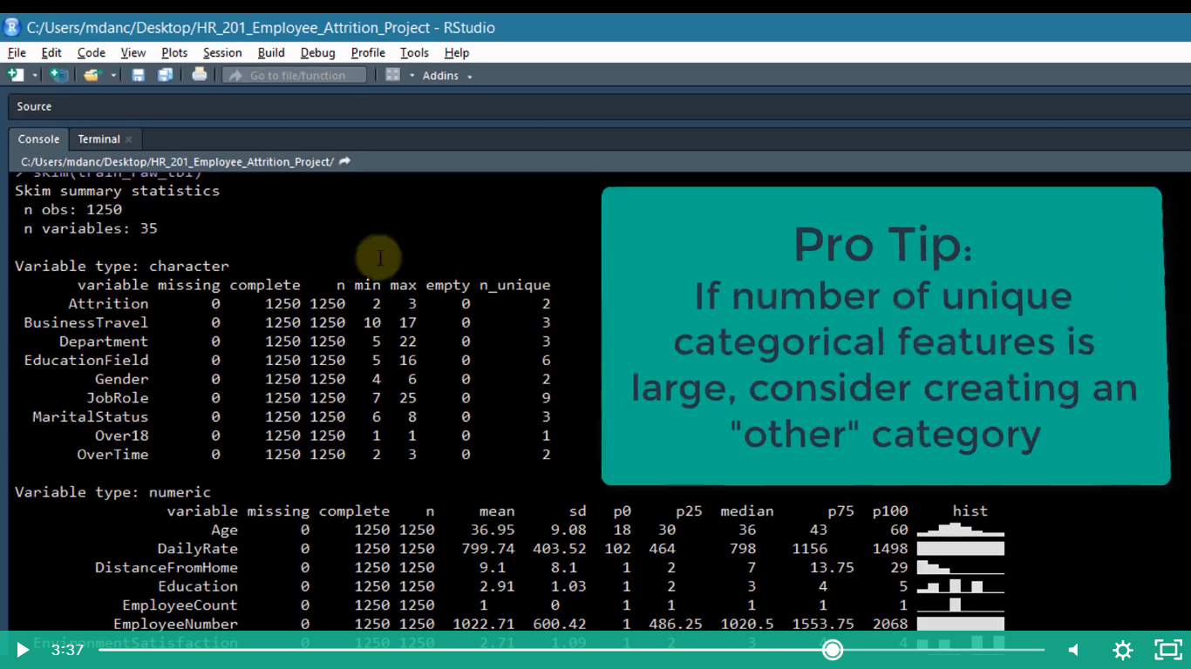

* **Histogram are very useful for analyzing numeric data (outliers, skew, should it be a factor?)**

1. **Exploring the character data and the numeric data**

**# Character Data type**

Train_raw_tbl %>%

Select_if(is.character) %>%

Glimpse()

* **Checking what are the levels:**

Train_raw_tbl %>%

Select_if(is.character) %>%

Map(unique)

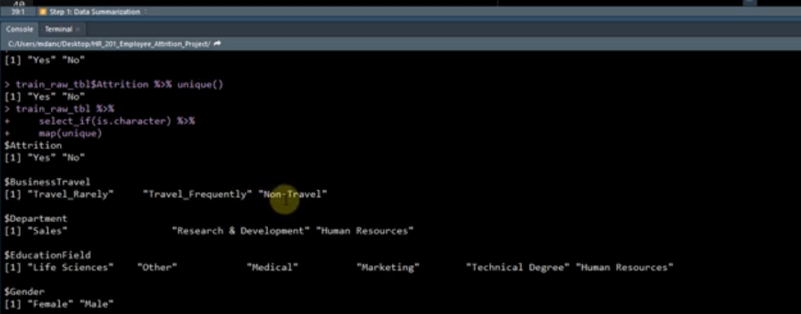

* **Checking what are number of observation for each level:**

Train_raw_tbl %>%

Select_if(is.character) %>%

Map(~table(.)) **# Anonymous Tidy function : can take anonymous functions that are not predefined. They begin with the tilde (~) and take dot (.) as the argument**

Train_raw_tbl %>%

Select_if(is.character) %>%

Map(~table(.)%>%prop.table()) # This convert the list created above to a table format

**#Numeric Data:**

Train_raw_tbl %>%

Select_if(is.numeric) %>%

Map_df(~unique(.)%>%length()) %>%

Gather() %>%

Arrange(value) %>%

Filter(value <=10)

**Map_df(): works exactly like map() except attempts to convert the list output to dataframe**

**Numeric variables that are lower in levels are likely to be discrete and numeric variables that are higher in levels are likely to be continuous.**

1. **Exploring the Feature- Target interactions with the GGally’s ggpairs and creating custom function for code reusability.**

**# Data Visualization:**

Train_raw_tbl %>%

Select(Attrition, Age, Gender, MaritalStatus, NumCompaniesWorked, Over18, DistanceFrom Home)%>%

Ggpairs()

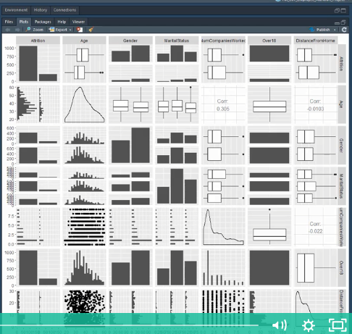

**Improving the above line of code we have:**

Train_raw_tbl %>%

Select(Attrition, Age, Gender, MaritalStatus, NumCompaniesWorked, Over18, DistanceFrom Home)%>%

Ggpairs(aes(color=attrition), lower=”blank”this removes the lower diagonal, legend=1, diag=list(continuous=wrap(“DensityDiag”, alpha=0.5 this is customization))) + theme(legend.position=”bottom”)

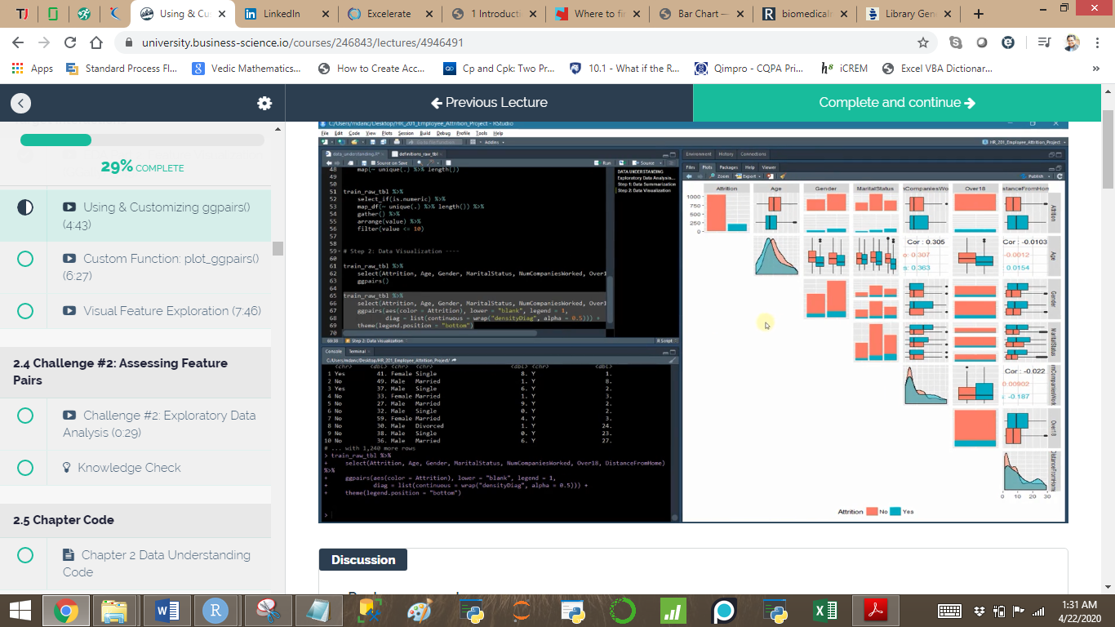

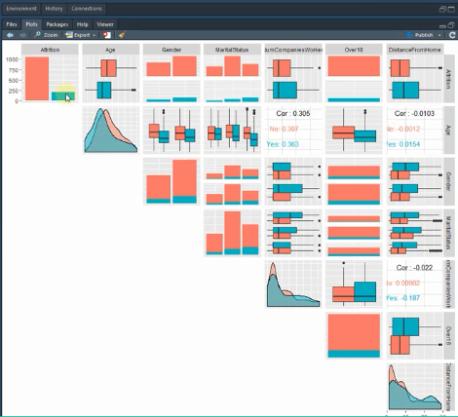

**Creating custom plot_ggpairs() function**

Plot_ggpairs <- function(data, color=NULL, density_alpha = 0.5) {

Color_expr <- enquo(color) **# we are using particular variable value and not variable for grouping**

If(rlang::quo_is_null(color_expr)) {

g <- data %>%

ggpairs(lower=”blank”) **#Dont include attrition by default for coloring**

}else{ color_name <-quo_name(color_expr) **# In the tidyeval way particular variable value is always accepted into the function with enquo and if is a value we can use it with !! else we can use it with quo_name**

<https://rlang.r-lib.org/reference/quosure.html>

g <- data %>%

ggpairs(mapping = aes_string(color=color_name),

lower=”blank”, legend=1,

diag= list(continuous= wrap(“densityDiag”, alpha=density_alpha))) +

theme(legend.position=”bottom”)

}

Return(g)

}

**#Now we can simplify the code**

Train_raw_tbl %>%

Select(Attrition, Age, Gender, MaritalStatus, NumCompaniesWorked, Over18, DistanceFrom Home)%>%

Plot_ggpairs(color=Attrition)

1. **Data preparation with recipes package. Files are kept in the 03_Data_Preparation Folder and in the Data_Preparation.R File**

Properly preparing data is an important aspect of the machine learning. It involve knowing the algorithm, goal and the data.

**This is a repeated procedure and hence we need to make a R file in the 00_Script folder and store the raw data there which we can import as per our convenience.**

#Install the packages

#Import the data:

Path_train <- “00_Data/telco_train.xlsx”

Path_test <- “00_Data/telco_test.xlsx”

Path_data_definitions <- “00_Data/telco_data_definitions.xlsx”

Train_raw_tbl <- read_excel(path_train, sheet=1)

Test_raw_tbl <- read_excel(path_test, sheet=1)

Definitions_raw_tbl <- read_excel(path_data_definitions, sheet=1, col_names=FALSE)

Definitions_raw_tbl %>%

Fill(X_1, .direction = “down”) **#fill() replaces missing values (NAs) with the closest entry (previous if direction = “down” or next if direction = “up”)**

1. **Creating custom histogram function to check the skewness and the Zero variance.**

We first create faceted histogram for every feature, to determine for which feature preprocessing step should be undertaken. We then format the data by the use correlation analysis for pre-modeling correlation analysis

Train_raw_tbl

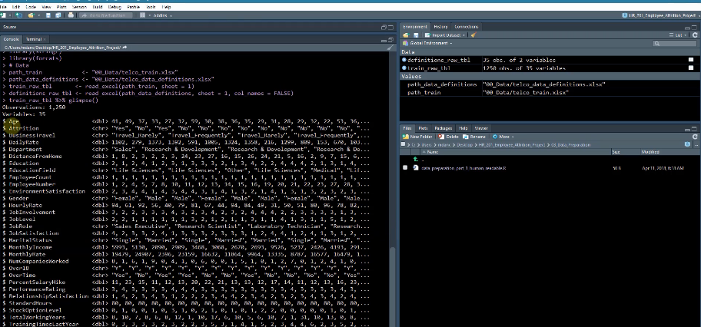

Plot_hist_facet <- function (data, bins =10, ncol=5, fct_reorder=FALSE, fct_rev=FALSE, fill=palette_light()[[3]], color=”white”, scale=”free”) **#palette_light come from tidyquant package and is used to color the bars**

{

data_factored <- data %>%

Mutate_if(is.character, as.factor) %>%

Mutate_if(is.factor, as.numeric) %>% **#as histogram don’t work with factor** 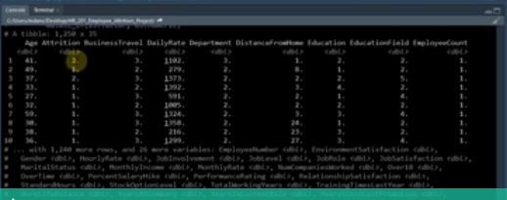

Gather(key= key, value=value, factor_key= TRUE) #**pivot_longer function can also be used, Here the key are the column and value are the corresponding values. Factor_key help in keeping the alphabetical order of the Key**

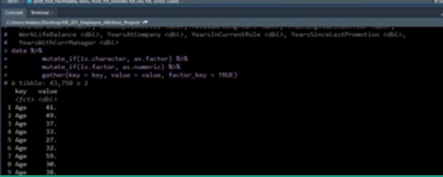

If(fct_reorder){ **#For the graph only**

Data_factored <- data_factored %>% mutate(key=as.character(key) %>% as.factor())

}

If(fct_rev) { **#For the graph only**

data_factored <- data_factored %>%

mutate(key=fct_rev(key))

}

g <- data_factored %>%

ggplot(aes(x=value, group=key)) +

geom_histogram(bins=bins, fill=fill, color=color) +

facet_wrap(~Key, ncol=ncol, scale=scale) +

theme_tq()

return(g)

}

Train_raw_tbl %>%

Select(Attrition,everything()) %>%

Plot_hist_facet(bins=10, ncol=5, fct_rev=F)

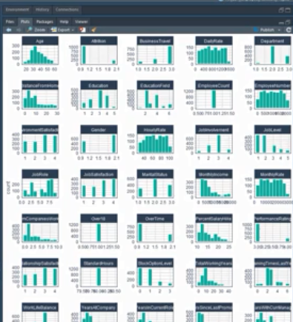

1. **Recipe: see the recipe package page,** <https://tidymodels.github.io/recipes/>

In recipes, there are no constraints related to the order in which steps are added to the recipe. However, there are some general suggestions that you should consider:

* If using a Box-Cox transformation, don’t center the data first or do any operations that might make the data non-positive. Alternatively, use the Yeo-Johnson transformation so you don’t have to worry about this.
* Recipes do not automatically create dummy variables (unlike *most* formula methods). If you want to center, scale, or do any other operations on *all* of the predictors, run step_dummy first so that numeric columns are in the data set instead of factors.
* As noted in the help file for step_interact, you should make dummy variables *before* creating the interactions.
* If you are lumping infrequently categories together with step_other, call step_other before step_dummy.

While your project’s needs may vary, here is a suggested order of *potential* steps that should work for most problems:

1. Impute
2. Individual transformations for skewness and other issues
3. Discretize (if needed and if you have no other choice)
4. Create dummy variables
5. Create interactions
6. Normalization steps (center, scale, range, etc)
7. Multivariate transformation (e.g. PCA, spatial sign, etc)
   1. **Zero variance features**

Recipe_obj <- recipe(Y~., data=train_readble_tbl) %>% step_zv(all_predictors())

**Step_.. identifies which variables required to be worked upon**

Recipe_obj

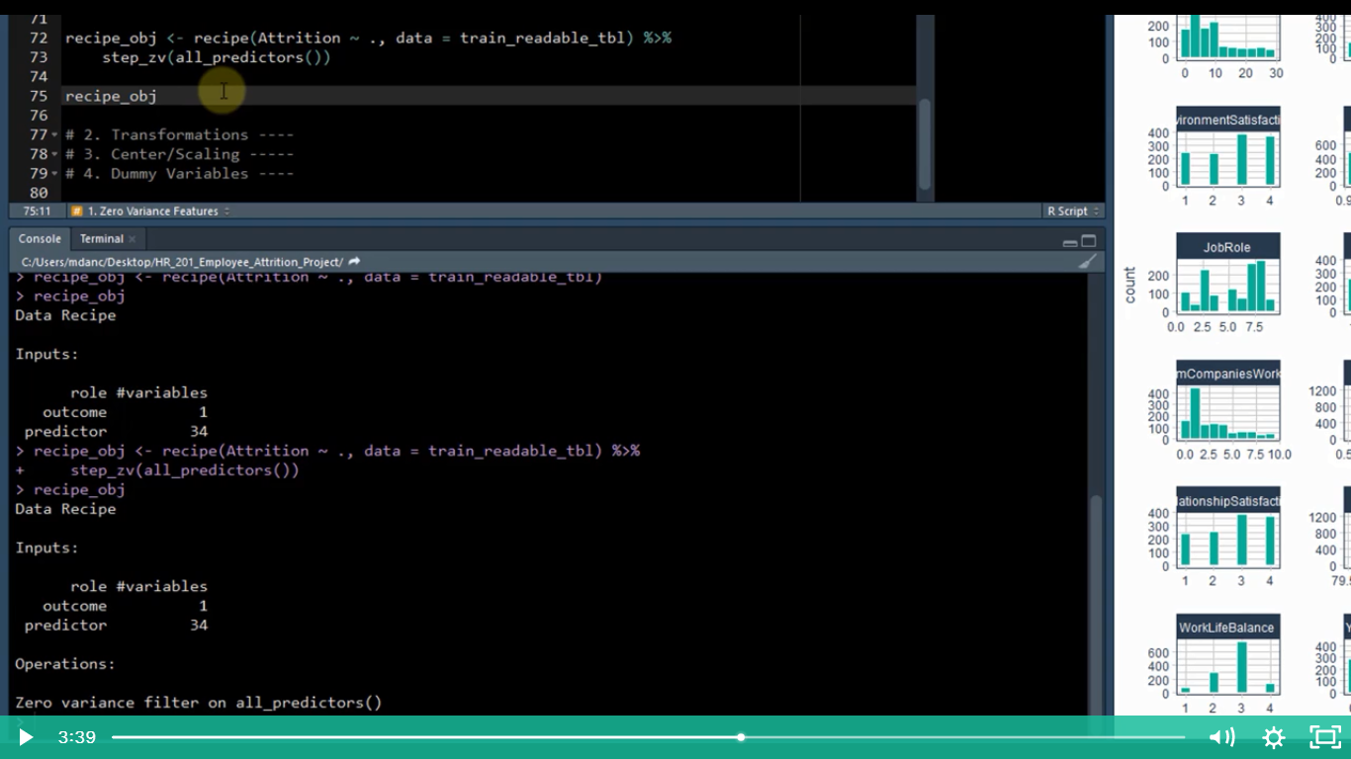

Recipe_obj %>% prep() **#prep prepares the recipe performing any calculations and essentially figuring out what to do. Prep doesn’t transform the data. It just figure out what transformations need to be performed.**

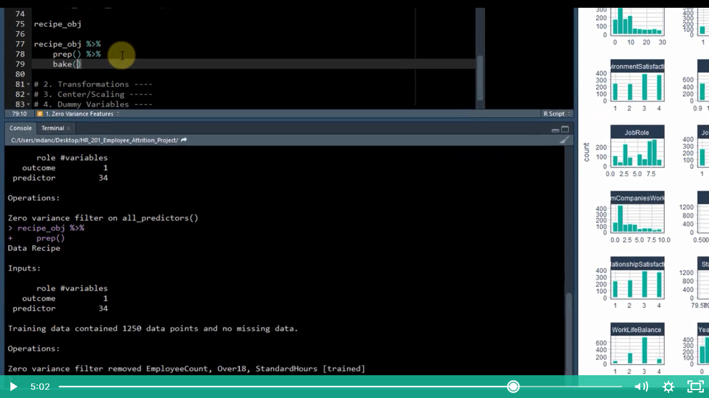

**The bake function perform the transformations on the new data. Once a recipe has instructions (step) and has been prepared, data can be transformed using the bake functions.**

**3 PART Process:**

* **Create the instructions with the recipes and step**
* **Prepare the recipe with step**
* **Bake new data**

Recipe_obj %>%

Prep() %>%

Bake(newdata= train_readable_tbl)

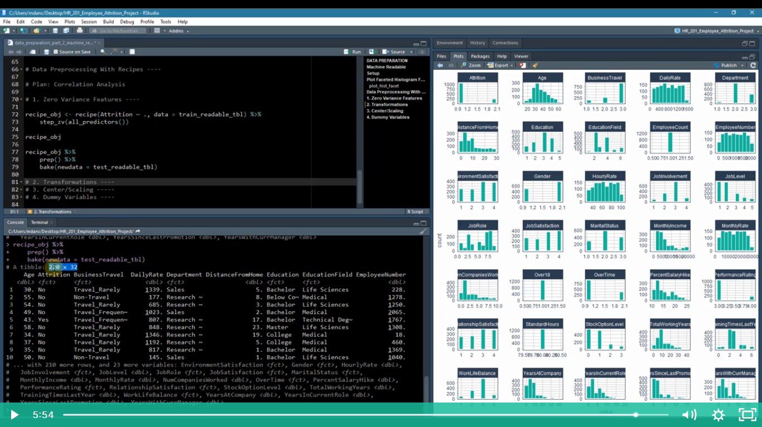

* 1. **Transformations**

Recipe_obj <- recipe(Attrition ~. , data=train_readable_tbl) %>%

Step_zv(all_predictors()) %>%

Step_YeoJohnson(only for skewed variables) %>% **# select the variables from train_raw_tbl %>% select_if(is.numeric) %>% map_df(skewness) skewness function is from PerformanceAnalytics pkg**

Step_num2factor(factor_names) **#this convert the numeric variables where less levels are there to factor**

**When we check the skewness**

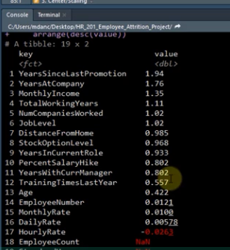

* 1. **Center and scaling**

Recipe_obj <- recipe(Attrition ~. , data=train_readable_tbl) %>%

Step_zv(all_predictors()) %>%

Step_YeoJohnson(only for skewed variables) %>% **# select the variables from train_raw_tbl %>% select_if(is.numeric) %>% map_df(skewness) skewness function is from PerformanceAnalytics pkg**

Step_num2factor(factor_names) **#this convert the numeric variables where less levels are there to factor**

Step_center(all_numeric()) %>%

Step_scale(all_numeric())

* 1. **Dummy variable**

Recipe_obj <- recipe(Attrition ~. , data=train_readable_tbl) %>%

Step_zv(all_predictors()) %>%

Step_YeoJohnson(only for skewed variables) %>% **# select the variables from train_raw_tbl %>% select_if(is.numeric) %>% map_df(skewness) skewness function is from PerformanceAnalytics pkg**

Step_num2factor(factor_names) **#this convert the numeric variables where less levels are there to factor**

Step_center(all_numeric()) %>%

Step_scale(all_numeric()) %>%

Step_dummy(all_nominal())

1. **Recipe -> doing the step -> prep -> bake**

With respect to the baking we apply the same on train and testing data

Train_tbl <- bake(recipe_obj, new_data=train_readable_tbl)

Test_tbl <- bake(recipe_obj, newdata=test_readable_tbl)

1. **Pre-modelling correlation analysis and creating custom correlation function:**

Why do we require Correlation analysis?

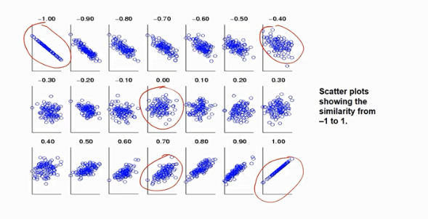

We need good feature before going to model

* Low correlation coefficient implies we should not go for modeling,

We should either

* 1. Get different data
  2. Inform boss analysis isn’t looking good
* If we have high correlation we should immediately report the stakeholders about the early detection and build strategies to improve decision making.

We can use the ggpair function from GGally package to see the correlation.

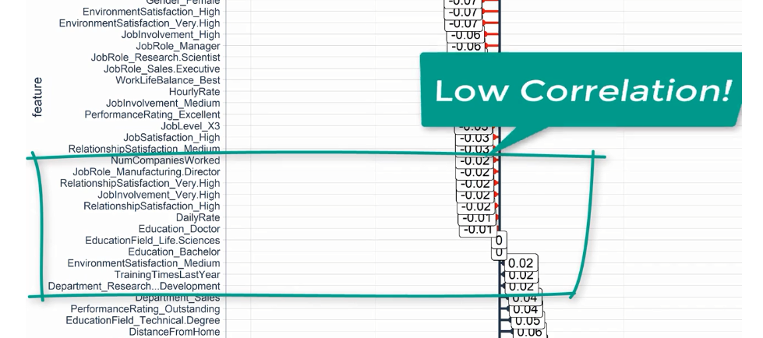

1. **Modelling setup with H2O AutoML. We will save this in the Folder 03_Modelling as Modelling_h2o_automated_ML.R**

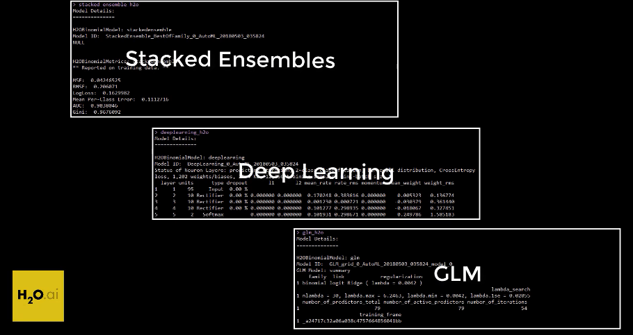

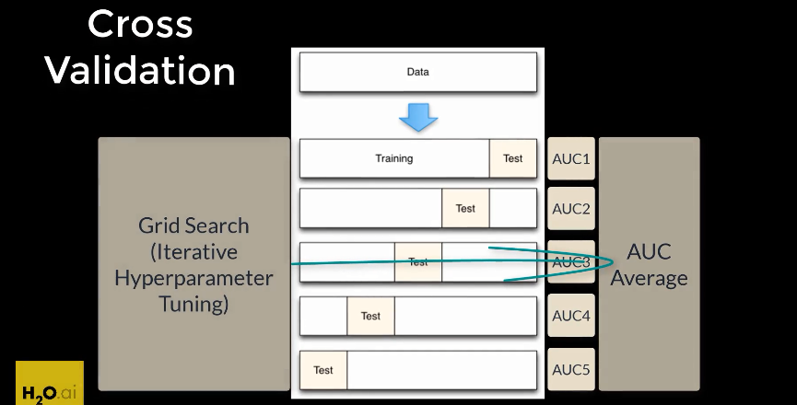

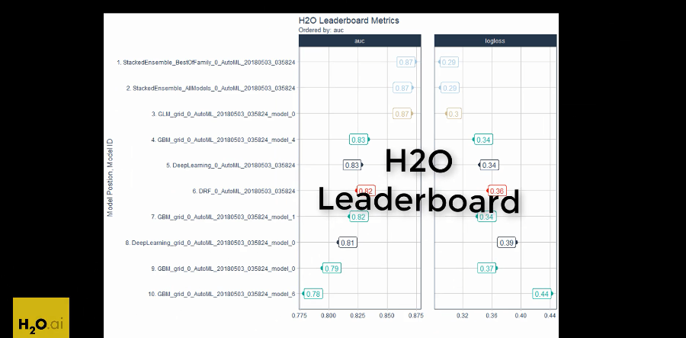

#Install the packages

#Import the data:

Path_train <- “00_Data/telco_train.xlsx”

Path_test <- “00_Data/telco_test.xlsx”

Path_data_definitions <- “00_Data/telco_data_definitions.xlsx”

Train_raw_tbl <- read_excel(path_train, sheet=1)

Test_raw_tbl <- read_excel(path_test, sheet=1)

Definitions_raw_tbl <- read_excel(path_data_definitions, sheet=1, col_names=FALSE)

Definitions_raw_tbl %>%

Fill(X_1, .direction = “down”) **#fill() replaces missing values (NAs) with the closest entry (previous if direction = “down” or next if direction = “up”)**

1. **Creating the preprocessing pipelines**

**H2o – low maintenance algorithm, handles factor and numeric data, perform preprocessing internally, data just needed to be in readable format, enable keeping that data in the readable format.**

#ML Preprocessing:

Recipe(Y~., data= train_readable_tbl) %>%

Step_zv(all_predictors()) %>%

Step_num2factor(JobLevel, StockOptionLevel)%>%

Prep()

Train_tbl <- bake(recipe_obj, newdata=train_readable_tbl)

test_tbl <- bake(recipe_obj, newdata=test_readable_tbl)

1. **H2O Modelling:**

**Deep Learning has a lot of feature and they can be seen h2o site**

**H2O AutoML does cross validation and grid search for us.**

**H2o is based on java.**

* **split_h2o<- h2o.splitFrame(as.h2o(train_tbl), ratios=c(0.85),seed=1234)**
* **train_h2o<- split_h2o[[1]]**
* **valid_h2o<-split_h2o[[2]]**
* **test_h2o<- as.h2o(test_tbl)**

**y <- “Attrition” #h2o needs to know which variable is target**

**x <- setdiff(names(train_h2o),y) #all names less Y**

**automl_models_h2o<- h2o.automl(**

**x=x,**

**y=y,**

**training_frame=train_h2o, #used to develop model**

**validation_frame=valid_h2o, #used to tune hyperparameter via grid search**

**leaderboard_frame=test_h2o, #test set completely held out from model training and tuning**

**max_runtime_secs =30,**

**nfolds=5, #cross validation**

**)**

1. **Inspecting the leader board**

Typeof(automl_models_h2o) #S4 object

slotNames(automl_models_h2o) #similar to names in S3 objects

automl_models_h2o@leaderboard

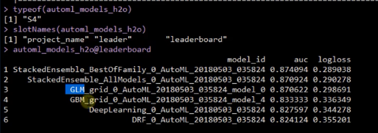

Automl_models_h2o@leader

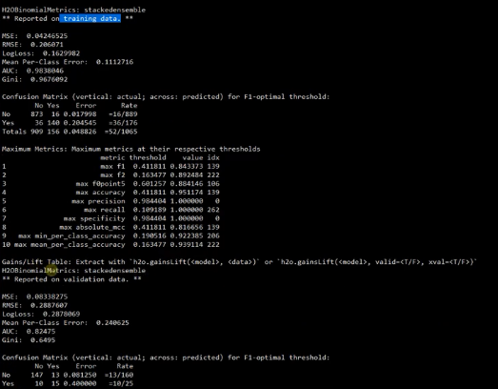



1. **Extracting the model from the leaderboard.**

Automl_models_h2o@leaderboard

Copy the specific model from the console

* h2o.getModel(“GLM_grid_0_AutoML_20180503_035824_model_0”)

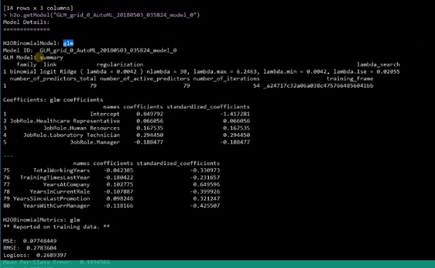

* **If we want to import the Models for plotting the comparative graph between different models**

**Automl_models_h2o@leaderboard %>%**

**As.tibble() %>%**

**Slice(1) %>%**

**Pull(model_id) %>% h2o.getModel()**

**Extract_h2o_model_name_by_position <- function(h2o_leaderboard, n=1, verbose= TRUE)**

#verbose is a nice way to depict messages within the code

**{**

**Model_name <- h2o_leaderboard %>% as.tibble() %>% slice(n) %>% pull(model_id)**

**If(verbose=TRUE) Message(model_name)**

**}**

**Automl_models_h2o@leaderboard %>%**

**Extract_h2o_model_name_by_position(2) %>%**

**H2o.getModel()**

1. **Making predictions**

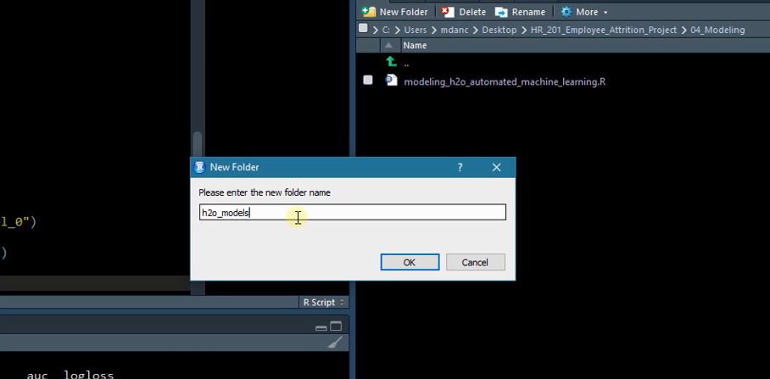

* h2o.getModel(“StackedEnsemble_BestOfFamily_......”) %>%

h2o.saveModel(path= “04_Modeling/h2o_models/”)

We can also load the model

H2o.loadModel(“04_Modeling/h2o_models/DeepLearning_0_AutoML_....”)

#Making Prediction:

Deep_learning_h2o<-H2o.loadModel(“04_Modeling/h2o_models/DeepLearning_0_AutoML_....”)

Deep_learning_h2o

H2o.predict(Deep_learning_h2o, newdata= as.h2o(test_tbl))

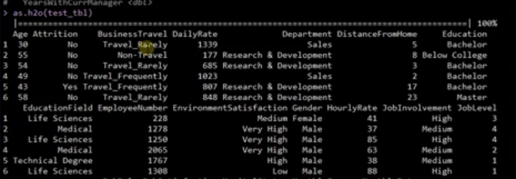

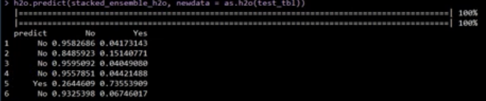

This model is saying for the 1st observation the employee not going is high probability

For binary classification: h2o prediction are 3 columns:

* 1. Class Prediction
* 2. 1st Class Probability
* 3. 2nd Class Probability

Predictions <- h2o.predict(deeplearning_h2o, newdata = as.h2o(test_tbl))

**#Removing the Target: the data argument must match the format that the model requires to predict. Since the h2o.predict() requires “x” to be without the target variable , we must remove.**

Prediction_tbl <- predictions %>% as.tibble()

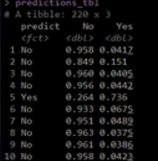

1. **Train, Validation & Leaderboard Frames + Model Parameters + Cross Validation + Hyper parameter Grid Search**
2. **Leaderboard visualization with ggplot2 and custom function**
3. **Revisiting the caret package for model (though caret package functionalities are not that advanced as H2O)**
4. **H2O Performance with auc, giniCoef, logloss, recall, F1, effect of threshold**
5. **Understanding the classification table: the meaning of it**
6. **Performance Charts:**
7. **Performance of Multiple models fs + purr**
8. **ROC Plot**
9. **Precision Vs Recall Plot**
10. **Gain and Lift calculation**
11. **Gain Plot and Lift Plot**

**J + K + L. Creating the ultimate model performance Comparison Dashboard:**

1. **Model diagnostic + metrics +gain +lift with cowplot**
2. **Feature Explanation with LIME: lime(), explain() (Local interpretable model-agnostic explanations)**

**LIME: Used to determine which features contribute to the prediction (& by how much) for a single observations**

<https://uc-r.github.io/lime>

**# Single Explanation: when we try to explain individual forecast**

**LIME 2 Steps**

**Step1: Build explainer with the lime()**

**Step2: Create an explanation with explain()**

**H2o, keras & caret : R Packages have been integrated into the lime**

**If you ever need to use an un- integrated package , you can do so by creating special functions :**

**Model_type()**

**Predict_model()**

**Explainer_object<- Train_tbl %>%**

**Select(-Attrition) %>%** #lime () create an “explainer” from the training data & model object.The returned object contains the ML Model and the feature distribution for the training data

**Lime( model=automl_leader,**

**Bin_continuous= TRUE, # Use bin_continuous to bin the features. It makes it easy to detect what causes the continuous feature to have a high feature weight in the explanation**

**n_bins=4,**

**quantile_bins=TRUE)**

**Explainer_object**

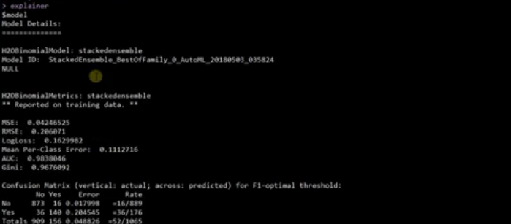

**Explanation <- Test_tbl %>%**

**Slice(5) %>%**

**Select(-Attrition Y) %>%**

**Lime::explain(**

**Explainer=explainer,**

**N_labels=1,**

**N_features=8,**

**N_permutations=5000,**

**Kernel_width= 1** #Affect the lime linear model fit (R squared value) and therefore should be tuned to make sure you get the best explanations

**)**

**Explanation**

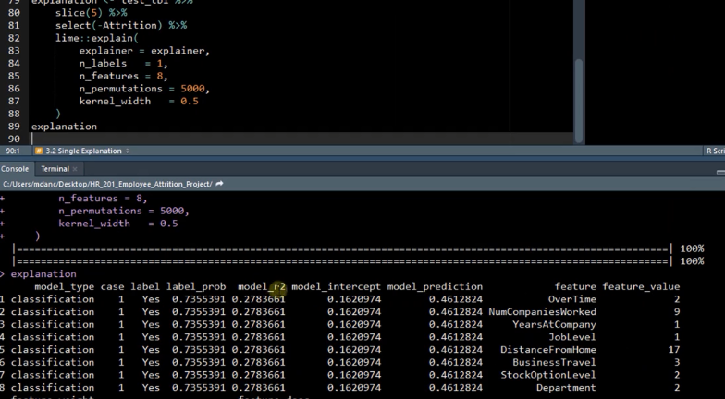

Explanation %>%

As.tibble %>%

Select(feature:prediction)

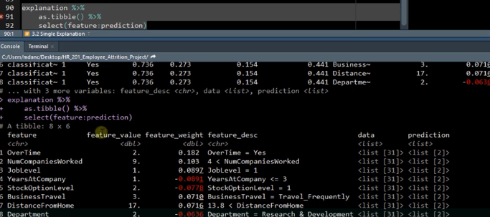

**Visualizing Feature importance for a single explanation plot_features()**

**Plot_features(explanation= explanation, ncol=1) #plot_features from lime package**

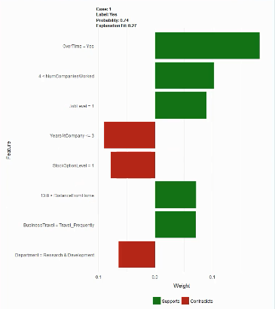

**Multiple explanation:**

**Explanation <- Test_tbl %>%**

**Slice(1:20) %>% #Explaining 1 to 20 observation**

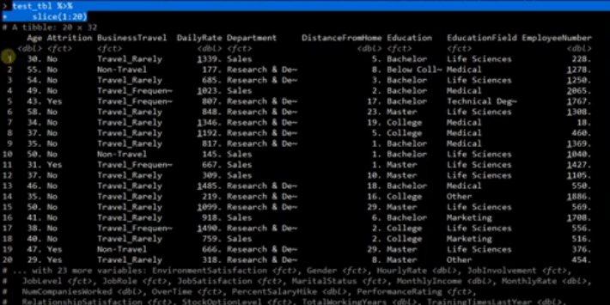

**Select(-Attrition Y) %>%**

**Lime::explain(**

**Explainer=explainer,**

**N_labels=1,**

**N_features=8,**

**N_permutations=5000,**

**Kernel_width= 1** #Affect the lime linear model fit (R squared value) and therefore should be tuned to make sure you get the best explanations

**)**

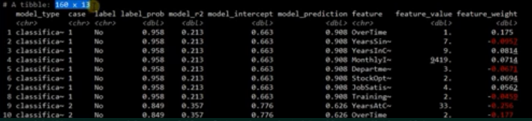

**Plot_feature(explanation= explanation, ncol=4)**

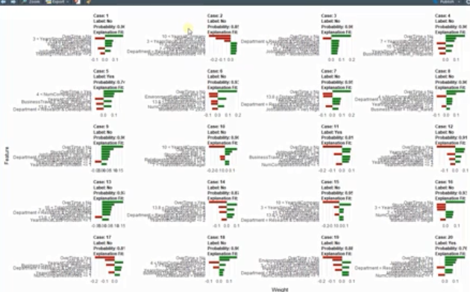

**Plot_explanations(explanation= explanation)**

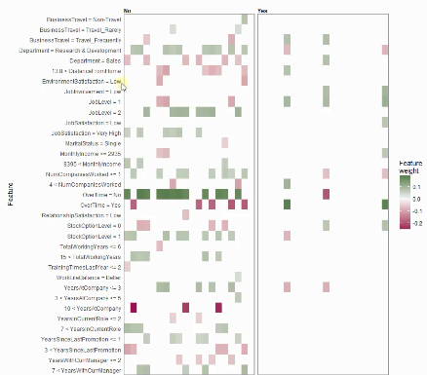

**LIME cannot be used for regression problems.**

* **Function used for visualizing multiple explanations -> plot explanations**
* **Function used for visualizing the explanation of a single observation-> plot_features**
* **The explanation has a feature weight. Positive indicate it supports the prediction, negative indicates it contradicts the prediction.**
* **Explain() function runs the lime algorithm using a model.**
* **If we choose to convert the numeric (continuous) features into 5 bins. Lime will make 6 cuts.**
* **Bin_continuous argument to lime() enables converting numeric values into bins.**
* **Lime allows us to explain models features for a single observations(locally)**

**Explaining how to read:**

**LIME Algorithm 6 Steps:**

* 1. Given an observation, permute it to create replicated feature data with slight value modifications.
  2. Compute similarity distance measure between original observation and permuted observations
  3. Apply selected Machine Learning model to predict outcomes of permuted data.
  4. Select m number of features to best describe predicted outcomes.
  5. Fit a simple model to the permuted data, explaining the complex model outcome with m features from the permuted data weighted by its similarity to the original observation
  6. Use the resulting feature weights to explain local behavior.

1. **Calculating the Expected ROI under different conditions in base line**
2. **Threshold optimization**
3. **Sensitivity Analysis: Visualizing the effect of scenarios and breakeven**
4. **Creating the recommendation algorithm.**

**PARALLEL AND DISTRIBUTED COMPUTING R**

<https://bookdown.org/rdpeng/rprogdatascience/parallel-computation.html>

**Qs1. When we need it? For importing data? Or For computing? Modelling?**

**Qs2. How much data can be processed by normal R?**

Many computations in R can be made faster by the use of parallel computation. Generally, parallel computation is the simultaneous execution of different pieces of a larger computation across multiple computing processors or cores. The basic idea is that if you can execute a computation in XX seconds on a single processor, then you should be able to execute it in X/nX/n seconds on nn processors.

It used to be that parallel computation was squarely in the domain of “high-performance computing”, where expensive machines were linked together via high-speed networking to create large clusters of computers.

You may be computing in parallel without even knowing it! These days, many computational libraries have built-in parallelism that can be used behind the scenes. Usually, this kind of “hidden parallelism” will generally not affect you and will improve you computational efficiency.

# **Why parallelism?**

Much R code runs fast and fine on a single processor. But at times, computations can be:

* **cpu-bound**: Take too much cpu time
* **memory-bound**: Take too much memory
* **I/O-bound**: Take too much time to read/write from disk
* **network-bound**: Take too much time to transfer

To help with **cpu-bound** computations, one can take advantage of modern processor architectures that provide multiple cores on a single processor, and thereby enable multiple computations to take place at the same time.

Historically, R has only utilized one processor, which makes it single-threaded.

<https://blog.dominodatalab.com/multicore-data-science-r-python/>

## R Packages

### **Parallel Package**

Package parallel was first included in R 2.14.0 and provides drop-in parallel replacements for most of the functionality of apply, with integrated handling of random-number generation.  
Parallelism can be done in computation at many different levels: this package is principally concerned with ‘coarse-grained parallelization’. The crucial point is that these chunks of computation are unrelated and do not need to communicate in any way.

In this sample code, we leverage parallel to read a directory of 100 csv files from a folder in parallel. This can allow us to leverage multicore architectures to parse and ingest data on disk more quickly.

|  |  |
| --- | --- |
| 1  2  3  4  5  6  7 | library(parallel)    numCores <- detectCores() # get the number of cores available    results <- mclapply(1:100,               FUN=function(i) read.csv(paste0("./data/datafile-", i, ".csv")),               mc.cores = numCores) |

The first multicore concepts introduced in this code are on line 3, where we call the detectCores() function to retrieve the number of cores available to this process. This queries the underlying operating system and returns an integer representing the number of processors. It’s important to note that often optimal parallelism does not mean using all cores available, as it may saturate other resources and cause thrashing, so remember to experiment and benchmark.

On line 5 we call the mclapply() (or multicore lapply) function imported from the parallel package. This is a nearly drop-in replacement for R’s venerable lapply function.

There are two differences practitioners should be aware of:

1. The mc.cores parameter provides the user a way to set the number of cores to leverage (in our case simply all cores detected).
2. The code in FUN is being executed inside of a separate R process, and therefore inherits forking semantics.

The main takeaway is that accessing global variables and dealing with global state will necessarily be different than when all code is executing in a single process.

Parallel provides a great tool to quickly scale up existing code with a few minor tweaks. It’s important to measure the true performance as the number of cores is scaled up and to remember that forking semantics will require some reorganization of code if global variables are used, however this can all be worth if it you want to speed up your code by over 100x!

### **Data.table**

Data.table is a venerable and powerful package written primarily by Matt Dowle. It is a high-performance implementation of R’s data frame construct, with an enhanced syntax. There have been innumerable benchmarks showcasing the power of the data.table package. It provides a highly optimized tabular data structure for most common analytical operations.

Matt Dowle cautions against using data.table in multicore environments, so why are discussing it in a multicore webinar and blog post? Announced in November of 2016, data.table got a fully parallelized version of fwrite! Allowing R to write out data with significant speedup!

In this sample code, we use the data.table fwrite package to write a large CSV leveraging multicore architectures.

|  |  |
| --- | --- |
| 01  02  03  04  05  06  07  08  09  10  11  12 | library(parallel)  library(data.table)    numCores <- detectCores()    nrows_mult <- 1000  ncols_mult <- 1000    big_data <- do.call("rbind", replicate(nrows_mult, iris, simplify = FALSE))  big_data <- do.call("cbind", replicate(ncols_mult, big_data, simplify = FALSE))    fwrite(big_data, "/tmp/bigdata.csv", nThread=numCores) |

In lines 6-10 we are replicating the iris dataset a number of times across to make it a very large in-memory data structure. This would take a significant amount of time to write to disk using standard tools.

To leverage multiple cores, on line 12 we call the fwrite() function with the parameter nThread with the number of cores we detected on line 4. There are limitations to the amount of parallelism that makes sense in this scenario, because the IO subsystem may not be able to keep up with massive numbers of threads, but as the benchmarks in the video show, it can make a significant difference; sometimes, writing out files 50% faster is the difference between success and failure.

### **Caret**

The caret package (Classification And REgression Training) is a set of functions that streamline the process for creating predictive models. The package contains tools for data splitting, preprocessing, feature selection, model tuning using resampling, variable importance estimation, and other functionality.

There are many different modeling functions in R. Some have different syntax for model training and/or prediction. The package began as a way to provide a uniform interface for the functions themselves, as well as to standardize common tasks such parameter tuning and variable importance.

The caret package leverages multicore functionality seamlessly and easily. It takes advantage of the fact that many of the operations—such as training with different hyperparemeters and cross validation—in model training are parallel.

In the sample code, we take advantage of caret’s multicore ability to train a glmnet model while doing a hyperparameter sweep and cross-validation:

|  |  |
| --- | --- |
| 1  2  3  4  5  6  7  8 | library(parallel)  library(doMC)  library(caret)    numCores <- detectCores()  registerDoMc(cores = numCores)    model_fit <- train(price ~ ., data=diamonds, method="glmnet", preProcess=c("center", "scale"), tuneLength=10) |

This code should look familiar by now. The primary difference comes at line 2 where we include the doMC package. This package provides a multicore “back-end” to the caret package, and handles all of the distribution of jobs across cores.

On line 6 we register the number of cores available to the doMC cluster.

On line 8 we train the model, doing some pre-processing on the values.

There is no need to pass the number of cores to caret, as it automatically inherits this information from the already created cluster.

There are a number of parameters that can be passed to caret. In this example we pass a tuneLength of 10, which creates a large tuning grid of hyperparemeters. This will create dozens if not hundreds of models with different configurations, and give us the best model based on optimizing the metric that makes the most sense, in this case RMSE.

### **Multidplyr**

Multidplyr is a backend for dplyr that partitions a data frame across multiple cores. You tell multidplyr how to split the data up with partition(), and then the data stays on each node until you explicitly retrieve it with collect(). This minimizes time spent moving data around, and maximizes parallel performance.

Due to the overhead associated with communicating between the nodes, you won’t see much performance improvement on basic dplyr verbs with fewer than ~10 million observations. However, you’ll see improvements much faster if you’re doing more complex operations with do().

In the sample code we use multidplyr to train a large number of GAM models on a dataset:

|  |  |
| --- | --- |
| 01  02  03  04  05  06  07  08  09  10  11  12  13  14  15  16  17  18  19 | library(multidplyr)  library(dplyr)  library(parallel)  library(nycflights13)    numCores <- detectCores()    cluster <- create_cluster(cores)    by_dest <- flights %>%   count(dest) %>%   filter(n >= 365) %>%   semi_join(flights, .) %>%   mutate(yday = lubridate::yday(ISOdate(year, month, day))) %>%   partition(dest, cluster = cluster)    cluster_library(by_dest, "mgcv")  models <- by_dest %>%   do(mod = gam(dep_delay ~ s(yday) + s(dep_time), data = .)) |

This code is slightly more complex than our previous examples. The main differences are that on line 8 we are explicitly initializing a cluster with the number of cores detected in line 6.

The multidplyr package handles all of the underlying challenges of spinning up the cluster, and does so in a transparent fashion for us via that simplified interface.

Lines 10-15 we are taking the flights dataset, doing some feature engineering to it, then partitioning it to the cluster on line 15.

This means we are taking subsets of the dataset and sending it to each one of the cores for processing. This abstraction is at a lower level than other abstractions such as caret’s, but it does allow us a significant amount of power to decide exactly how code is distributed across multiple cores.

On line 17 we broadcast to the cluster that it will require the “mgcv” library in order to execute the following pipeline.

Finally, on lines 18 and 19, we train a large number of GAM models in parallel across the cluster, each partitioned by the destination.

Multidplyr is still an early package and is being used by Hadley and his team to work through and understand how to bring multicore power to the tidyverse. It is useful now for a number of use cases and is an exciting preview of things to come.

**USE CASES IN MARKETING:**

Understanding Markets: Conjoint Analysis

Product profile: representing the combinations of attributes.

A linear model fit to preference rankings is an example of traditional conjoint analysis, a modeling technique designed to show how product attributes affect purchasing decisions.

Marketing analysts present product profiles to consumers. Product profiles are defined by their attributes.

By ranking, rating, or choosing products, consumers reveal their preferences for products and the

Corresponding attributes that define products.

The computed attribute importance values and part worth associated with levels of attributes represent measurements that are obtained as a group or jointly—thus the name conjoint analysis.

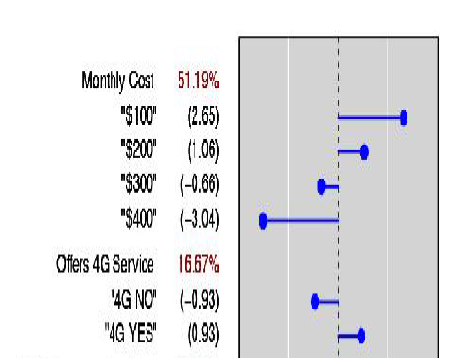

The part-worth of each level of each attribute is displayed as a dot with a connecting horizontal

line, extending from the spine. Preferred product or service characteristics have positive part-worths

and fall to the right of the spine. Less preferred product or service characteristics fall to the left of

the spine.

The spine chart shows standardized part-worths and attribute importance values. The relative

importance of attributes in a conjoint analysis is defined using the ranges of part-worths within

attributes. These importance values are scaled so that the sum across all attributes is 100 percent.

Conjoint analysis is a measurement technology. Part-worths and attribute importance values are

conjoint measures.

What does the spine chart say about this consumer’s preferences? It shows that monthly

cost is of considerable importance. Next in order of importance is 4G availability.

Traditional conjoint analysis represents a modeling technique in predictive analytics. Working with

groups of consumers, we fit a linear model to each individual’s ratings or rankings, thus measuring

the utility or part-worth of each level of each attribute, as well as the relative importance of

attributes.

Conjoint measures can be used to predict each individual’s choices in the marketplace.

Furthermore, using conjoint measures, we can perform marketplace simulations, exploring

alternative product designs and pricing policies.

Consumers reveal their preferences in responses to surveys and ultimately in choices they make in the

marketplace.

They want to know what is important to choice or which factors determine choice.

To the extent that buyer behavior is affected by product features, brand, and price, managers are able to

influence buyer behavior, increasing demand, revenue, and profitability.

Ask buyers what they want, and they may say, *the best of everything.* Ask them what they would liketo spend, and they may say, *as little as possible.*

There are limitations to assessing buyer willingness to pay and product preferences with direct response

rating scales.

Conjoint measurement, a critical tool of marketing data science, focuses on buyers or the demand side

of markets.

Primary applications of conjoint analysis fall under the headings of new product

design and pricing research.

<https://tidyr.tidyverse.org/reference/expand.html>

[library](https://rdrr.io/r/base/library.html)(dplyr)

# All possible combinations of vs & cyl, even those that aren't

# present in the data

expand(mtcars, vs, cyl)

#> # A tibble: 6 x 2

#> vs cyl

#> *<dbl>* *<dbl>*

#> 1 0 4

#> 2 0 6

#> 3 0 8

#> 4 1 4

#> 5 1 6

#> 6 1 8

# Only combinations of vs and cyl that appear in the data

expand(mtcars, nesting(vs, cyl))

#> # A tibble: 5 x 2

#> vs cyl

#> *<dbl>* *<dbl>*

#> 1 0 4

#> 2 0 6

#> 3 0 8

#> 4 1 4

#> 5 1 6

# Implicit missings ---------------------------------------------------------

df <- [tibble](https://tibble.tidyverse.org/reference/tibble.html)(

year = [c](https://rdrr.io/r/base/c.html)(2010, 2010, 2010, 2010, 2012, 2012, 2012),

qtr = [c](https://rdrr.io/r/base/c.html)( 1, 2, 3, 4, 1, 2, 3),

return = [rnorm](https://rdrr.io/r/stats/Normal.html)(7)

)

df %>% expand(year, qtr)

#> # A tibble: 8 x 2

#> year qtr

#> *<dbl>* *<dbl>*

#> 1 2010 1

#> 2 2010 2

#> 3 2010 3

#> 4 2010 4

#> 5 2012 1

#> 6 2012 2

#> 7 2012 3

#> 8 2012 4

df %>% expand(year = 2010:2012, qtr)

#> # A tibble: 12 x 2

#> year qtr

#> *<int>* *<dbl>*

#> 1 2010 1

#> 2 2010 2

#> 3 2010 3

#> 4 2010 4

#> 5 2011 1

#> 6 2011 2

#> 7 2011 3

#> 8 2011 4

#> 9 2012 1

#> 10 2012 2

#> 11 2012 3

#> 12 2012 4

df %>% expand(year = [full_seq](https://tidyr.tidyverse.org/reference/full_seq.html)(year, 1), qtr)

#> # A tibble: 12 x 2

#> year qtr

#> *<dbl>* *<dbl>*

#> 1 2010 1

#> 2 2010 2

#> 3 2010 3

#> 4 2010 4

#> 5 2011 1

#> 6 2011 2

#> 7 2011 3

#> 8 2011 4

#> 9 2012 1

#> 10 2012 2

#> 11 2012 3

#> 12 2012 4

df %>% [complete](https://tidyr.tidyverse.org/reference/complete.html)(year = [full_seq](https://tidyr.tidyverse.org/reference/full_seq.html)(year, 1), qtr)

#> # A tibble: 12 x 3

#> year qtr return

#> *<dbl>* *<dbl>* *<dbl>*

#> 1 2010 1 -1.40

#> 2 2010 2 0.255

#> 3 2010 3 -2.44

#> 4 2010 4 -0.00557

#> 5 2011 1 NA

#> 6 2011 2 NA

#> 7 2011 3 NA

#> 8 2011 4 NA

#> 9 2012 1 0.622

#> 10 2012 2 1.15

#> 11 2012 3 -1.82

#> 12 2012 4 NA

# Nesting -------------------------------------------------------------------

# Each person was given one of two treatments, repeated three times

# But some of the replications haven't happened yet, so we have

# incomplete data:

experiment <- [tibble](https://tibble.tidyverse.org/reference/tibble.html)(

name = [rep](https://rdrr.io/r/base/rep.html)([c](https://rdrr.io/r/base/c.html)("Alex", "Robert", "Sam"), [c](https://rdrr.io/r/base/c.html)(3, 2, 1)),

trt = [rep](https://rdrr.io/r/base/rep.html)([c](https://rdrr.io/r/base/c.html)("a", "b", "a"), [c](https://rdrr.io/r/base/c.html)(3, 2, 1)),

rep = [c](https://rdrr.io/r/base/c.html)(1, 2, 3, 1, 2, 1),

measurement_1 = [runif](https://rdrr.io/r/stats/Uniform.html)(6),

measurement_2 = [runif](https://rdrr.io/r/stats/Uniform.html)(6)

)

# We can figure out the complete set of data with expand()

# Each person only gets one treatment, so we nest name and trt together:

all <- experiment %>% expand(nesting(name, trt), rep)

all

#> # A tibble: 9 x 3

#> name trt rep

#> *<chr>* *<chr>* *<dbl>*

#> 1 Alex a 1

#> 2 Alex a 2

#> 3 Alex a 3

#> 4 Robert b 1

#> 5 Robert b 2

#> 6 Robert b 3

#> 7 Sam a 1

#> 8 Sam a 2

#> 9 Sam a 3

# We can use anti_join to figure out which observations are missing

all %>% [anti_join](https://dplyr.tidyverse.org/reference/join.html)(experiment)

#> **Joining, by = c("name", "trt", "rep")**

#> # A tibble: 3 x 3

#> name trt rep

#> *<chr>* *<chr>* *<dbl>*

#> 1 Robert b 3

#> 2 Sam a 2

#> 3 Sam a 3

# And use right_join to add in the appropriate missing values to the

# original data

experiment %>% [right_join](https://dplyr.tidyverse.org/reference/join.html)(all)

#> **Joining, by = c("name", "trt", "rep")**

#> # A tibble: 9 x 5

#> name trt rep measurement_1 measurement_2

#> *<chr>* *<chr>* *<dbl>* *<dbl>* *<dbl>*

#> 1 Alex a 1 0.402 0.290

#> 2 Alex a 2 0.196 0.678

#> 3 Alex a 3 0.404 0.735

#> 4 Robert b 1 0.0637 0.196

#> 5 Robert b 2 0.389 0.981

#> 6 Robert b 3 NA NA

#> 7 Sam a 1 0.976 0.742

#> 8 Sam a 2 NA NA

#> 9 Sam a 3 NA NA

# Or use the complete() short-hand

experiment %>% [complete](https://tidyr.tidyverse.org/reference/complete.html)(nesting(name, trt), rep)

#> # A tibble: 9 x 5

#> name trt rep measurement_1 measurement_2

#> *<chr>* *<chr>* *<dbl>* *<dbl>* *<dbl>*

#> 1 Alex a 1 0.402 0.290

#> 2 Alex a 2 0.196 0.678

#> 3 Alex a 3 0.404 0.735

#> 4 Robert b 1 0.0637 0.196

#> 5 Robert b 2 0.389 0.981

#> 6 Robert b 3 NA NA

#> 7 Sam a 1 0.976 0.742

#> 8 Sam a 2 NA NA

#> 9 Sam a 3 NA NA

# Generate all combinations with expand():

formulas <- [list](https://rdrr.io/r/base/list.html)(

formula1 = Sepal.Length ~ Sepal.Width,

formula2 = Sepal.Length ~ Sepal.Width + Petal.Width,

formula3 = Sepal.Length ~ Sepal.Width + Petal.Width + Petal.Length

)

data <- [split](https://rdrr.io/r/base/split.html)(iris, iris$Species)

crossing(formula = formulas, data)

#> **Error: `x` must be a vector, not a `formula` object**

**#Multi-level full profile conjoint analysis:**

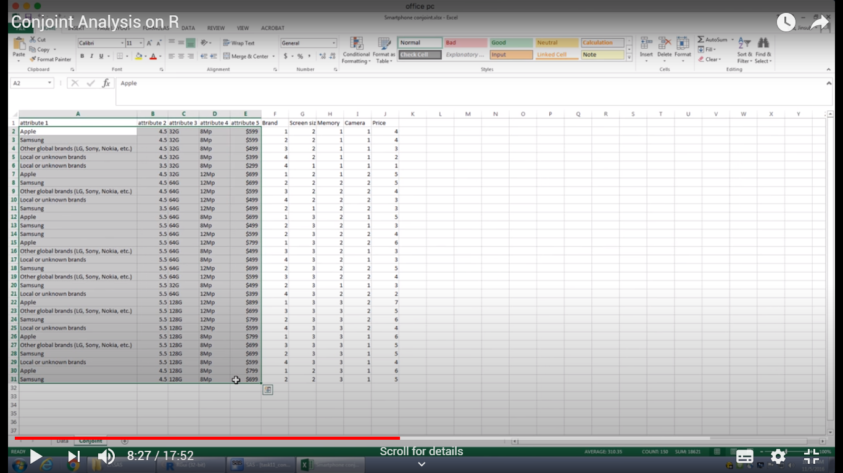

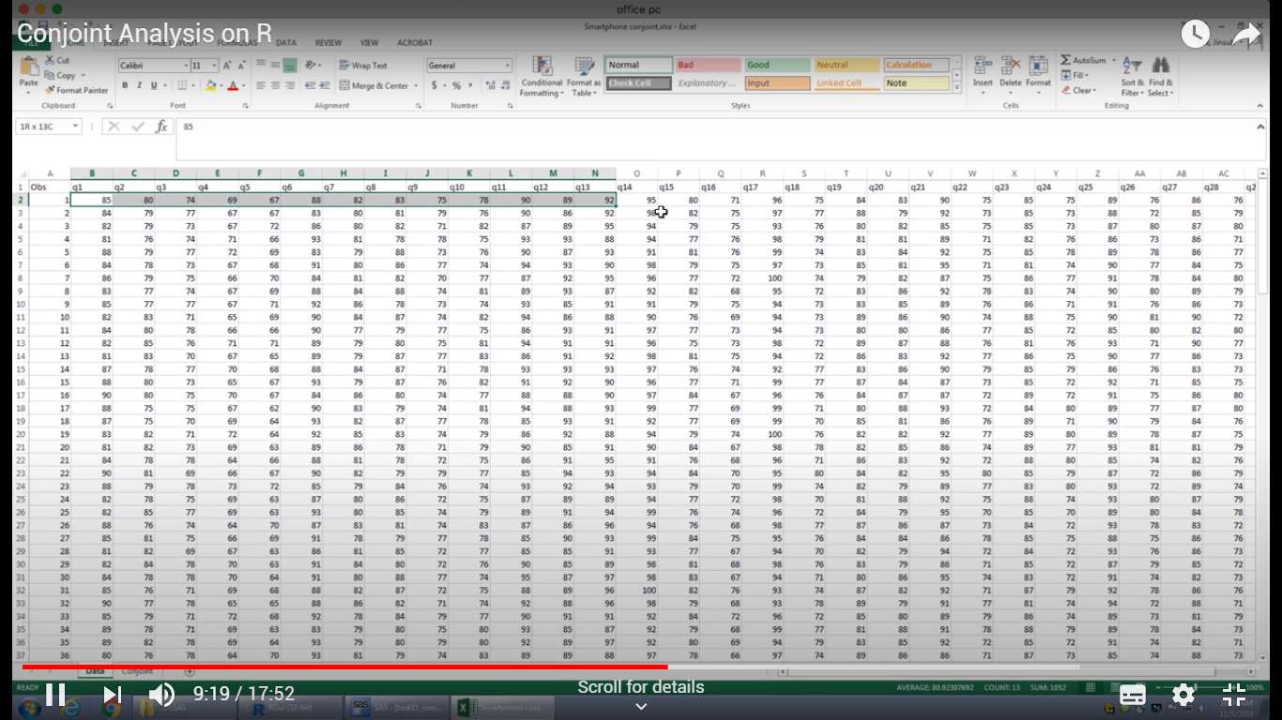

**150 customer surveyed, 30 variable.**

